What I built:
I built a D1 time series forecasting pipeline using XGBoost to predict future values from engineered lagged and rolling features on tabular financial data.
Problem it solves:
Classic statistical time series models such as ARIMA struggle with non-stationary, noisy financial data, so this approach reframes forecasting as a supervised learning problem that is more stable, scalable, and production-ready.
XGBoost Model — How it Works
- Data collation and preprocessing
  - All balance, credit, and debit values are first aggregated by date so that each row represents a daily snapshot.
  - Dates are converted into a standard datetime format, and any missing credit or debit values are filled with zero to ensure consistency.
  - This produces a clean, daily time-indexed dataset suitable for forecasting.
- Calendar and time-based feature engineering (create_time_features)
  - I generate deterministic time features from the date index, including day of week, day of month, week of year, month, and quarter.
  - Binary indicators such as weekend flags and month start/end are also added.
  - A date offset and a binned seasonal feature are created to capture broader seasonal regimes.
  - These features allow the model to learn recurring calendar effects like weekday patterns and month-end behavior.
- Transaction pattern features (create_transaction_features)
  - Raw transaction data is transformed into structured signals: daily credits, daily debits, and net daily cash flow.
  - To capture short-term memory effects, I add lagged versions of these signals at 1, 3, and 7 days.
  - This step injects domain-specific financial behavior beyond just historical balance values.
- Lag features of the target variable (create_lag_features)
  - The balance time series is converted into supervised learning inputs by creating lagged features from 1 to 14 days.
  - Each lag represents the balance at a previous time step.
  - This effectively “tabularizes” the time series so XGBoost can learn non-linear mappings from past to future.
- Rolling window statistics (create_rolling_features)
  - For rolling windows of 3, 7, 14, and 30 days, I compute shifted rolling means, standard deviations, minimums, and maximums.
  - Importantly, all rolling calculations are shifted by one day before aggregation to prevent look-ahead leakage.
  - This ensures the model only uses information that would have been available at the prediction time.
- Handling missing values from feature construction (prepare_data)
  - Lag and rolling operations naturally create missing values at the beginning of the dataset.
  - These rows are removed so that the model is trained only on complete and valid feature vectors.
- Chronological train–test split (train_test_split)
  - The data is split strictly in time order rather than randomly.
  - The earlier portion of the dataset is used for training, and the later portion is reserved for testing.
  - This mirrors real-world deployment and avoids information leakage from the future.
- Training the XGBoost regressor (fit)
  - Feature columns are selected by excluding the target variable and non-predictive metadata.
  - An XGBoost regressor is trained using these features, with evaluation performed on both training and test sets.
  - XGBoost itself is an ensemble of boosted decision trees, allowing it to capture complex non-linear interactions in the data.
- Prediction and evaluation (evaluate)
  - The trained model generates forecasts on the test set.
  - Performance is evaluated using MAE, RMSE, and MAPE to capture absolute, squared, and relative error behavior.
- Monte Carlo simulation for probabilistic forecasting
- To move beyond point predictions, I model uncertainty by analyzing the historical forecast errors.
- These errors are approximated using a parametric normal distribution with estimated mean and variance.
- I then ran 1,000 Monte Carlo simulations by sampling random shocks from this distribution and adding them to the model’s forecast.
- This produces a full distribution of possible future outcomes, allowing us to quantify uncertainty, downside risk, and tail scenarios rather than relying on a single forecast value.
Input:
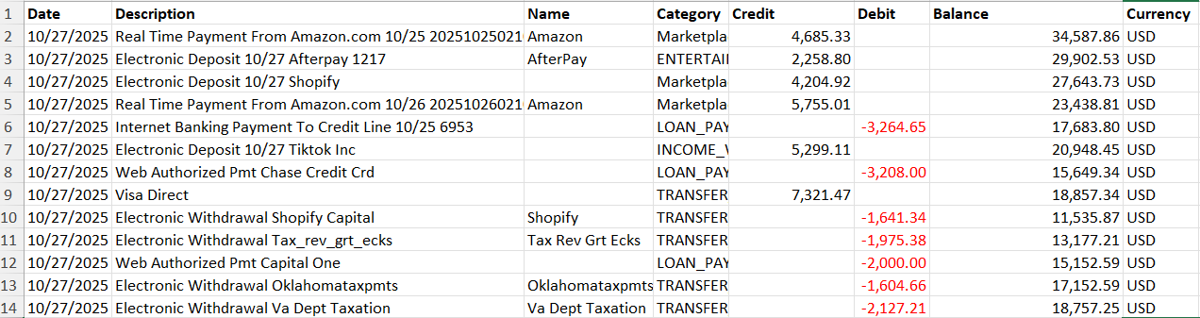
Output:
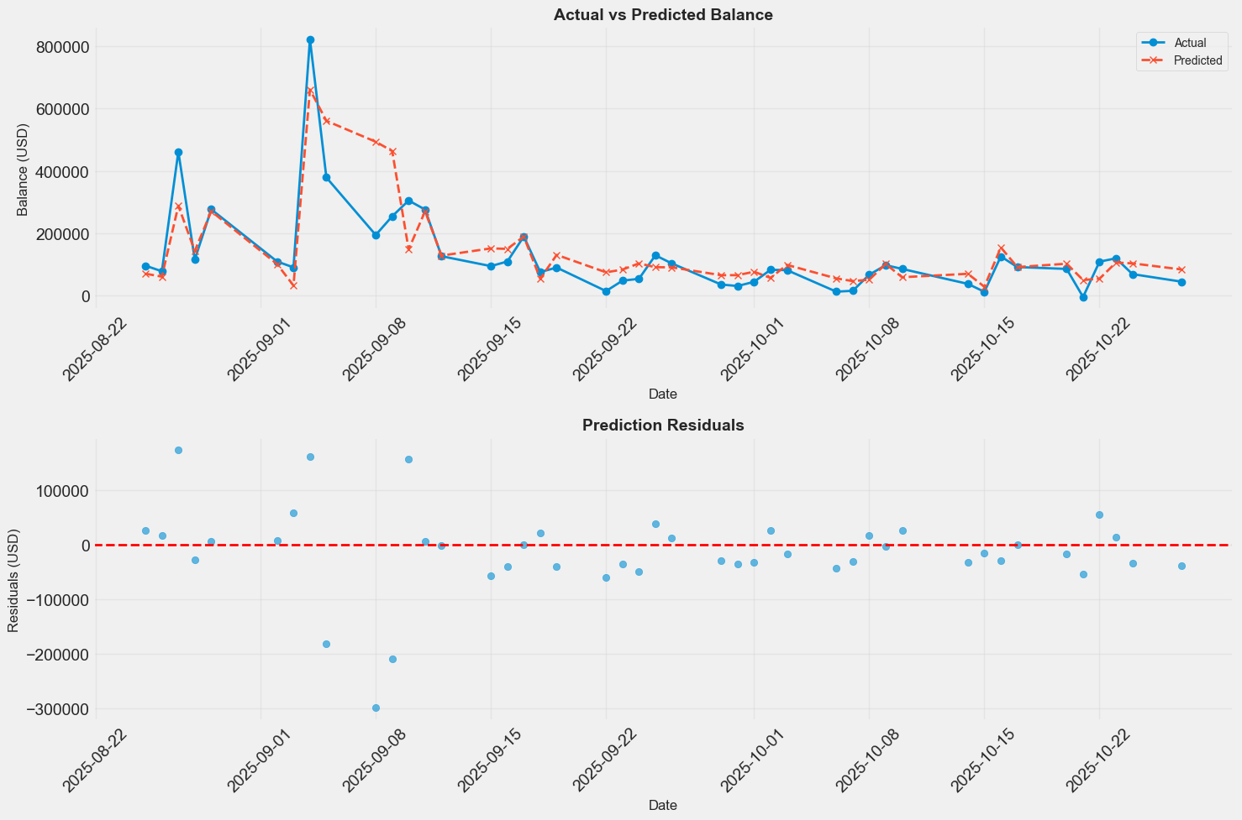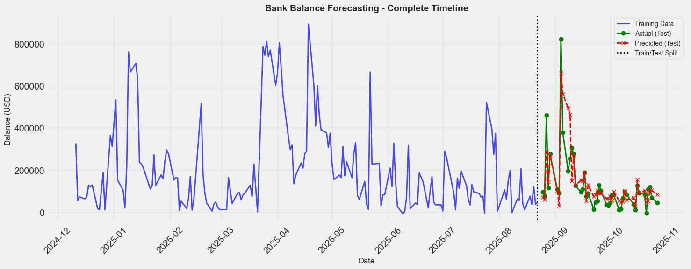

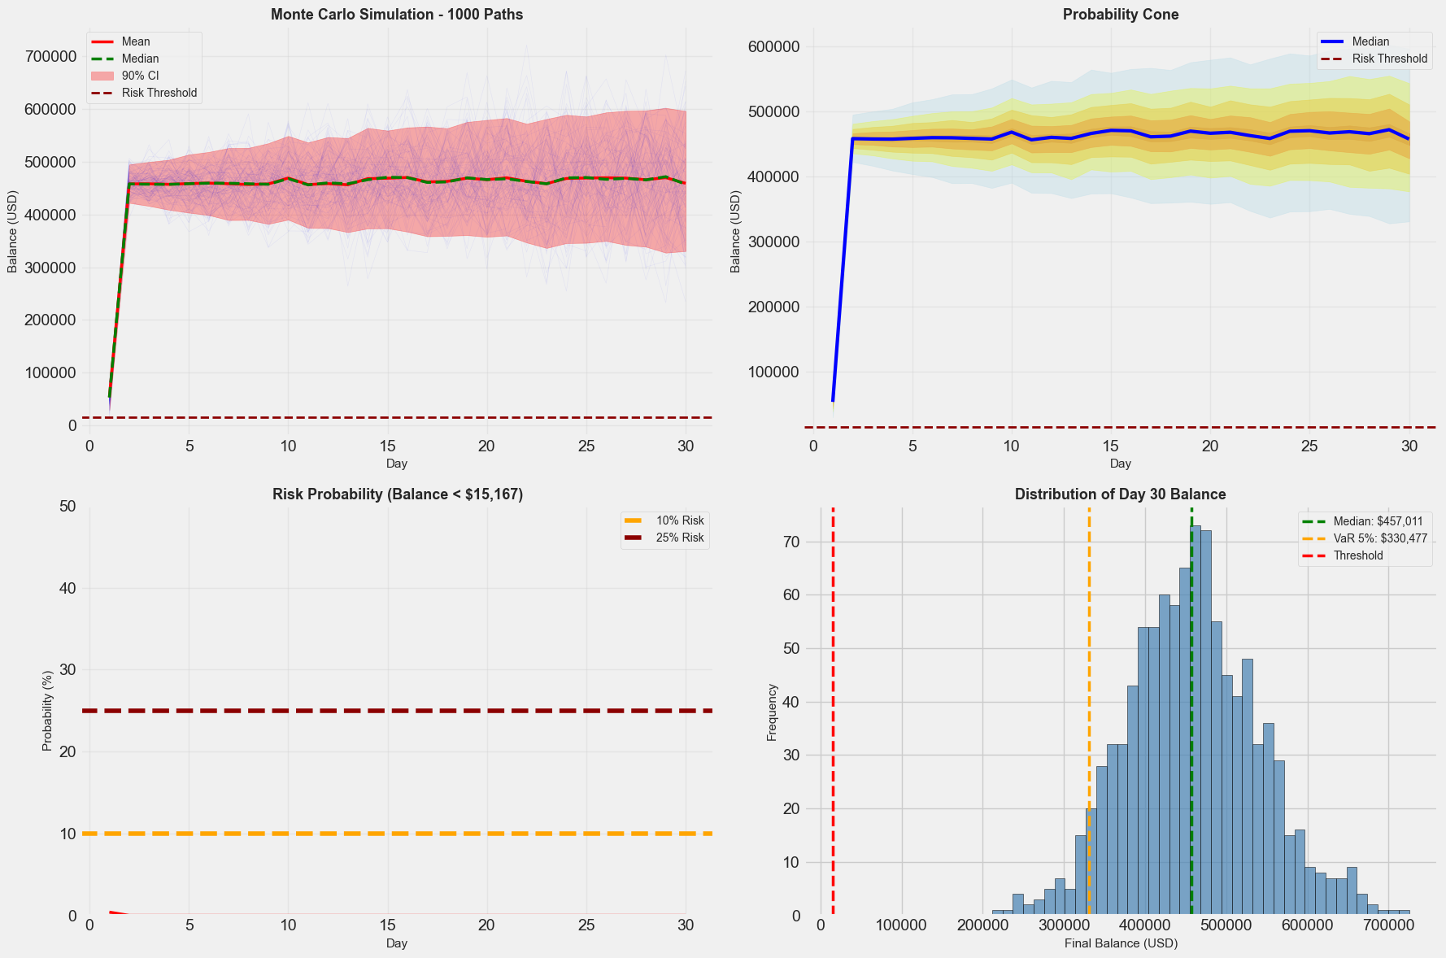

This visualization shows how we extend a point forecast into a full, risk-aware forecast using Monte Carlo simulation. Starting from the XGBoost model’s daily prediction, we simulate 1,000 possible future balance paths by sampling from the model’s historical residuals, which allows us to capture uncertainty and tail risk. The fan of paths and probability cone illustrate how forecast uncertainty widens over time, while the median balance remains stable around $450,000. Importantly, this framework lets us quantify downside risk: the probability of the balance falling below the risk threshold remains close to zero throughout the horizon, and the distribution of outcomes at Day 30 shows that even in the worst 5% of scenarios, the balance is still above roughly $300,000. Rather than producing a single number, this approach provides a full distribution of plausible futures, enabling more informed, risk-aware decision-making.

Limitation: Limited data and time-series cross-validation stability

Cross-validation output analysis
Training set: 175 days
From: 2024-12-11 00:00:00
To: 2025-08-22 00:00:00

Test set: 44 days
From: 2025-08-25 00:00:00
To: 2025-10-27 00:00:00
CV summary: {'RMSE_mean': 127777.62883142475, 'RMSE_std': 47314.48436443681, 'MAE_mean': 99499.71108506939, 'MAE_std': 30089.801425830552}
Fold metrics:
{'fold': 1, 'n_train': 44, 'n_val': 11, 'n_test': 30, 'MAE': 127407.57085416676, 'RMSE': 186968.56811580397, 'best_iteration': None}
{'fold': 2, 'n_train': 68, 'n_val': 17, 'n_test': 30, 'MAE': 57725.685098958274, 'RMSE': 71157.81505318805, 'best_iteration': None}
{'fold': 3, 'n_train': 92, 'n_val': 23, 'n_test': 30, 'MAE': 113365.87730208311, 'RMSE': 125206.50332528222, 'best_iteration': None}

- As a limitation of this example, the dataset is relatively small, so I used a time-series split cross-validation rather than a random split to avoid look-ahead bias.
- The training window spans 175 days, from December 2024 to August 2025, with a 44-day hold-out test period from August to October 2025.
- To assess robustness, the model was evaluated across three expanding-window folds, where each fold trains on progressively more historical data and tests on a fixed forward horizon.
- Across these folds, we observe noticeable variation in MAE and RMSE, with MAE ranging from roughly $58k to $127k.
- This variability is expected and highlights a key limitation: the dataset is not large enough to fully stabilize model performance across different market regimes. Early folds, in particular, have shorter training histories, which makes the model more sensitive to noise and regime shifts.
- The cross-validation summary reflects this, with a mean RMSE of about $128k and a relatively large standard deviation, indicating uncertainty in out-of-sample performance.
- Importantly, this does not indicate a flaw in the modeling approach, but rather demonstrates that time-series models benefit significantly from longer historical coverage, especially when using feature-rich methods like XGBoost.
- With additional data, we would expect the fold-to-fold variance to shrink, improving generalization and allowing more reliable estimates of forecast accuracy.

